# Hall Switch Experiment

## Introduction

While a sheet of live metal or semiconductor is placed vertically in a magnetic field, a potential difference occurs between the ends of the sheet, a phenomenon known as the Hall-effect. The electric difference between the two ends is called Hall potential U, and its expression is **U=Kk·I·B/d**. The Hall switch USES this principle. **3144** Series Hall switch is a magnetic sensing circuit composed of voltage regulator, Hall voltage generator, check amplifier, Schmitt trigger, temperature compensator, etc. Its input is magnetic induction intensity, and its output is a digital voltage signal. It has the characteristics of small volume, high sensitivity, fast response speed and good temperature performance. Typical applications include safety alarm device, noncontacting switch, etc.

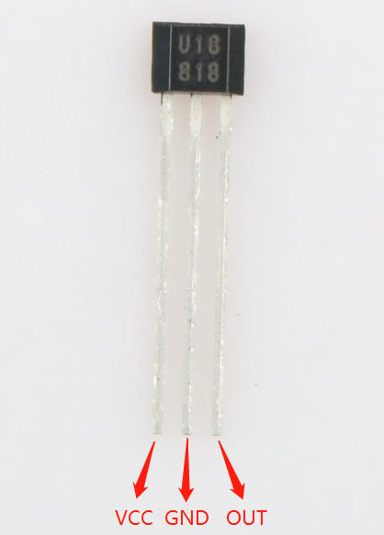

Hall Switch Module

### Hall Switch Classification

**1、Unipolar Hall Effect Switch(Digital Output)**

The unipolar Hall effect switch has a magnetic operating threshold (**Bop**). If the Hall cell is subjected to a flux density greater than the operating threshold, the output transistor will be turned on. When the flux density drops below the operating threshold (**Brp**), the transistor shuts down. Hysteresis (**Bhys**) is the difference between two thresholds (**BOP-BRP**). This built-in hysteresis page enables a net switch of output even in the presence of external mechanical vibration and electrical noise. The digital output of the unipolar Hall effect may be adapted to various logical systems. These devices are ideal for use with simple magnetic bars or rods. Unipolar Hall switch will specify a magnetic pole induction on both sides of the switch to be effective. In specific applications, attention should be paid to the installation of the magnetic pole of the magnet; otherwise, reverse installation will cause unipolar noninductive output.

**2、Bipolar Hall Effect switch(Digital Output)**

The bipolar Hall switch is divided into two types: the bipolar unlatched Hall switch and the bipolar latched Hall switch.

The bipolar Hall switch is usually switched on if the Magnetic field at the S-pole is strong enough and off if the magnetic field at the N-pole is strong enough. However, if the magnetic field is removed, it is a random output, either on or off. The bipolar latched-type Hall-effect switch is usually switched on if the Magnetic field at the S-pole is strong enough and off if the magnetic field at the N-pole is strong enough, but does not change the output state if the magnetic field is removed. These Hall-effect switches may be magnetically driven by north-south alternating magnetic fields and multipole ring magnets.

**3、Bipolar Latched Hall Effect switch(Digital Output)**

While placed at the N-pole (or S-pole), the magnetic field remains on after removal. It is only closed when placed at the S-pole (or N-pole), and remains on or off after the magnetic field is removed until the next magnetic field changes. This property of preserving the last state is the latch property, and this type of Hall benefit switch is the bipolar latched Hall-effect switch.

**4、Omnipolar Latched Hall Effect switch(Digital Output)**

Unlike other Hall-effect switches, these devices may be able to be turned on as long as there is a strong enough North or South magnetic field. The output shuts off while there is no magnetic field.

**5、Linear Hall Effect switch(Digital Output)**

The voltage output of the linear Hall-effect sensor IC accurately tracks the flux density change. At a static (non-magnetic) state, the output should theoretically be equal to half of the supply voltage within the operating voltage and operating temperature range. Increasing the S-Pole magnetic field will increase the voltage from its static voltage. Instead, increasing the N-Pole's magnetic field will increase the voltage from its static voltage. These units measure the Angle of current, proximity, motion, and magnetic flux, which may be able to reflect mechanical events in a magnetically driven manner.

**6、Low-Power consumption Hall Effect switch(Digital Output)**

With the popularity of mobile phones, laptops, **DV** and other portable devices, the power consumption of Hall **IC** is required, thus a new class of Hall **IC** is produced. It is a kind of digital Hall **IC** separated by power consumption. Its internal sleep mechanism is adopted to reduce power consumption, and its average power consumption may reach uA level. It may also be divided into three types according to the function: single-pole Hall **IC**, latched hall **IC**, and Omnipolar Hall **IC**, which is generally used for battery long - term power supply system.

## Experimental Purpose

* Understand the principle of the Hall switch
* Use Hall switches to control the LED on or off

## Experimental Principle

While the Hall switch is powered on, when there is no magnetic flux through the Hall switch, the switch is in the off state. While objects with magnets and other magnetic sensing lines are close to the Hall switch, a magnetic flux is generated to enable the Hall switch to conduct, making the LED on and the buzzer sound.

## Component List

* Raspberry Pi main board
* Raspberry Pi expansion board
* Breadboard
* Cable
* Hall Switch Module *1
* LED *1
* Active Buzzer *1
* Several jumper wires

## Wiring

|  |  |
| --- | --- |
| Raspberry Pi | Hall Sensor |
| IO3(wiringPi)/22(BCM) | S |
| 5V | VCC |
| GND | GND |

|  |  |
| --- | --- |
| Raspberry Pi | LED |
| IO5(wiringPi)/24(BCM) | + |
| GND | — |

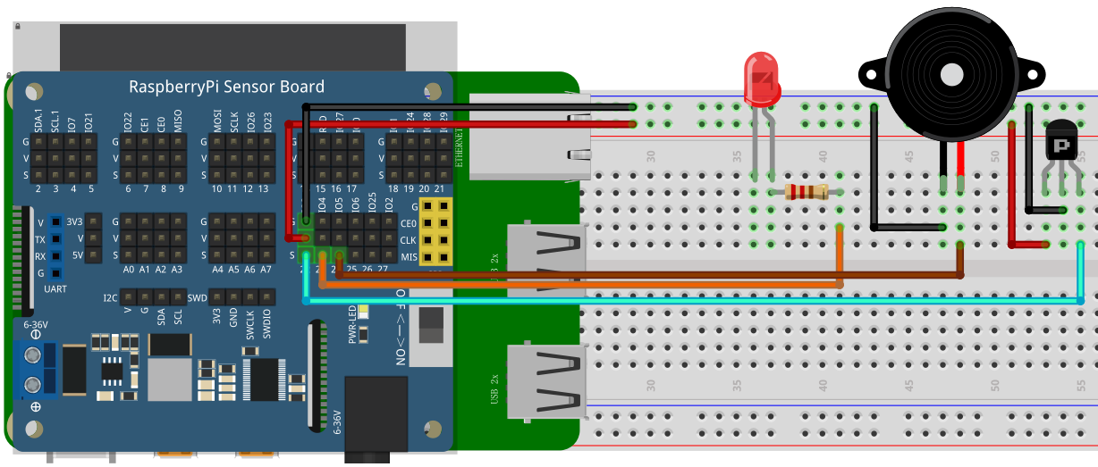

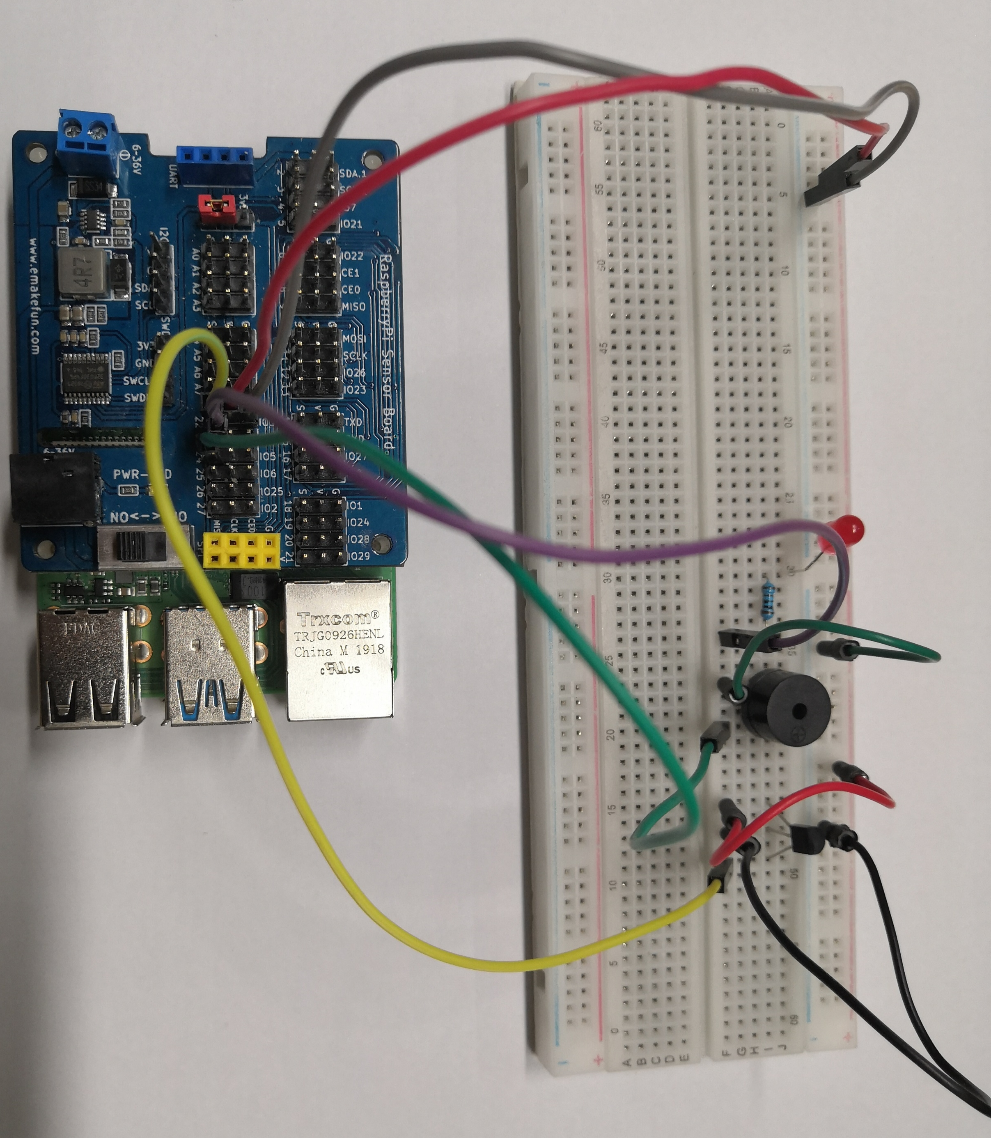

## C++ program

|  |
| --- |
| #include <stdio.h>  #include <wiringPi.h>  using namespace std**;**  #define Sensor 3  #define Buzzer 4  #define led 5  int main **()**  **{**  int val**;**  wiringPiSetup**();**  pinMode**(**Buzzer**,** OUTPUT**);**  pinMode**(**led**,** OUTPUT**);**  pinMode**(**Sensor**,** INPUT**);**  **while(**1**)**  **{**  val**=**digitalRead**(**Sensor**);**//将数字接口的值读取赋给val  **if(**val**==**0**)**  **{**  digitalWrite**(**Buzzer**,** HIGH**);**  digitalWrite**(**led**,** HIGH**);**  delay**(**1000**);**  **}**  **else**  **{**  digitalWrite**(**Buzzer**,** LOW**);**  digitalWrite**(**led**,** LOW**);**  **}**  **}**  **}** |

## Python program

|  |
| --- |
| import RPi**.**GPIO as GPIO  import time  Sensor **=** 22  Buzzer **=** 23  led **=** 24  GPIO**.**setmode**(**GPIO**.**BCM**)**  GPIO**.**setup**(**Buzzer**,** GPIO**.**OUT**)**  GPIO**.**setup**(**led**,** GPIO**.**OUT**)**  GPIO**.**setup**(**Sensor**,** GPIO**.**IN**)**  **while** True**:**  **if** not GPIO**.**input**(**Sensor**):**  GPIO**.**output**(**Buzzer**,** GPIO**.**HIGH**)**  GPIO**.**output**(**led**,** GPIO**.**HIGH**)**  time**.**sleep**(**1**)**  **else:**  GPIO**.**output**(**Buzzer**,** GPIO**.**LOW**)**  GPIO**.**output**(**led**,** GPIO**.**LOW**)**  GPIO**.**clearnup**()** |

## Java program

|  |
| --- |
| **import** java**.**util**.**concurrent**.**Callable**;**  **import** com**.**pi4j**.**io**.**gpio**.**GpioController**;**  **import** com**.**pi4j**.**io**.**gpio**.**GpioFactory**;**  **import** com**.**pi4j**.**io**.**gpio**.**GpioPinDigitalInput**;**  **import** com**.**pi4j**.**io**.**gpio**.**GpioPinDigitalOutput**;**  **import** com**.**pi4j**.**io**.**gpio**.**PinPullResistance**;**  **import** com**.**pi4j**.**io**.**gpio**.**PinState**;**  **import** com**.**pi4j**.**io**.**gpio**.**RaspiPin**;**  **import** com**.**pi4j**.**io**.**gpio**.**trigger**.**GpioCallbackTrigger**;**  **import** com**.**pi4j**.**io**.**gpio**.**trigger**.**GpioPulseStateTrigger**;**  **import** com**.**pi4j**.**io**.**gpio**.**trigger**.**GpioSetStateTrigger**;**  **import** com**.**pi4j**.**io**.**gpio**.**trigger**.**GpioSyncStateTrigger**;**  public class Hall **{**    public static void main**(**String**[]** args**)** **throws** InterruptedException **{**  // create gpio controller  final GpioController gpio **=** GpioFactory**.**getInstance**();**  // provision gpio pin #02 as an input pin with its internal pull down resistor enabled  final GpioPinDigitalInput Sensor **=** gpio**.**provisionDigitalInputPin**(**RaspiPin**.**GPIO_03**,**  PinPullResistance**.**PULL_UP**);**  // setup gpio pins #04, #05, #06 as an output pins and make sure they are all LOW at startup  GpioPinDigitalOutput TAB**[]** **=** **{**  gpio**.**provisionDigitalOutputPin**(**RaspiPin**.**GPIO_04**,** "Buzzer"**,** PinState**.**LOW**),**  gpio**.**provisionDigitalOutputPin**(**RaspiPin**.**GPIO_05**,** "led"**,** PinState**.**LOW**),**  **};**  // create a gpio pulse trigger on the input pin; when the input goes LOW, also pulse gpio pin to the HIGH state for 1 second  Sensor**.**addTrigger**(new** GpioPulseStateTrigger**(**PinState**.**LOW**,** TAB**[**0**],** 1000**));**  Sensor**.**addTrigger**(new** GpioPulseStateTrigger**(**PinState**.**LOW**,** TAB**[**1**],** 1000**));**    **for** **(;;)** **{**  Thread**.**sleep**(**500**);**  **}**  **}**  **}** |

## Experimental Effect

Using a magnet close to the Hall switch causes the Hall switch to output a low level voltage and making the LED on and the buzzer sound.

